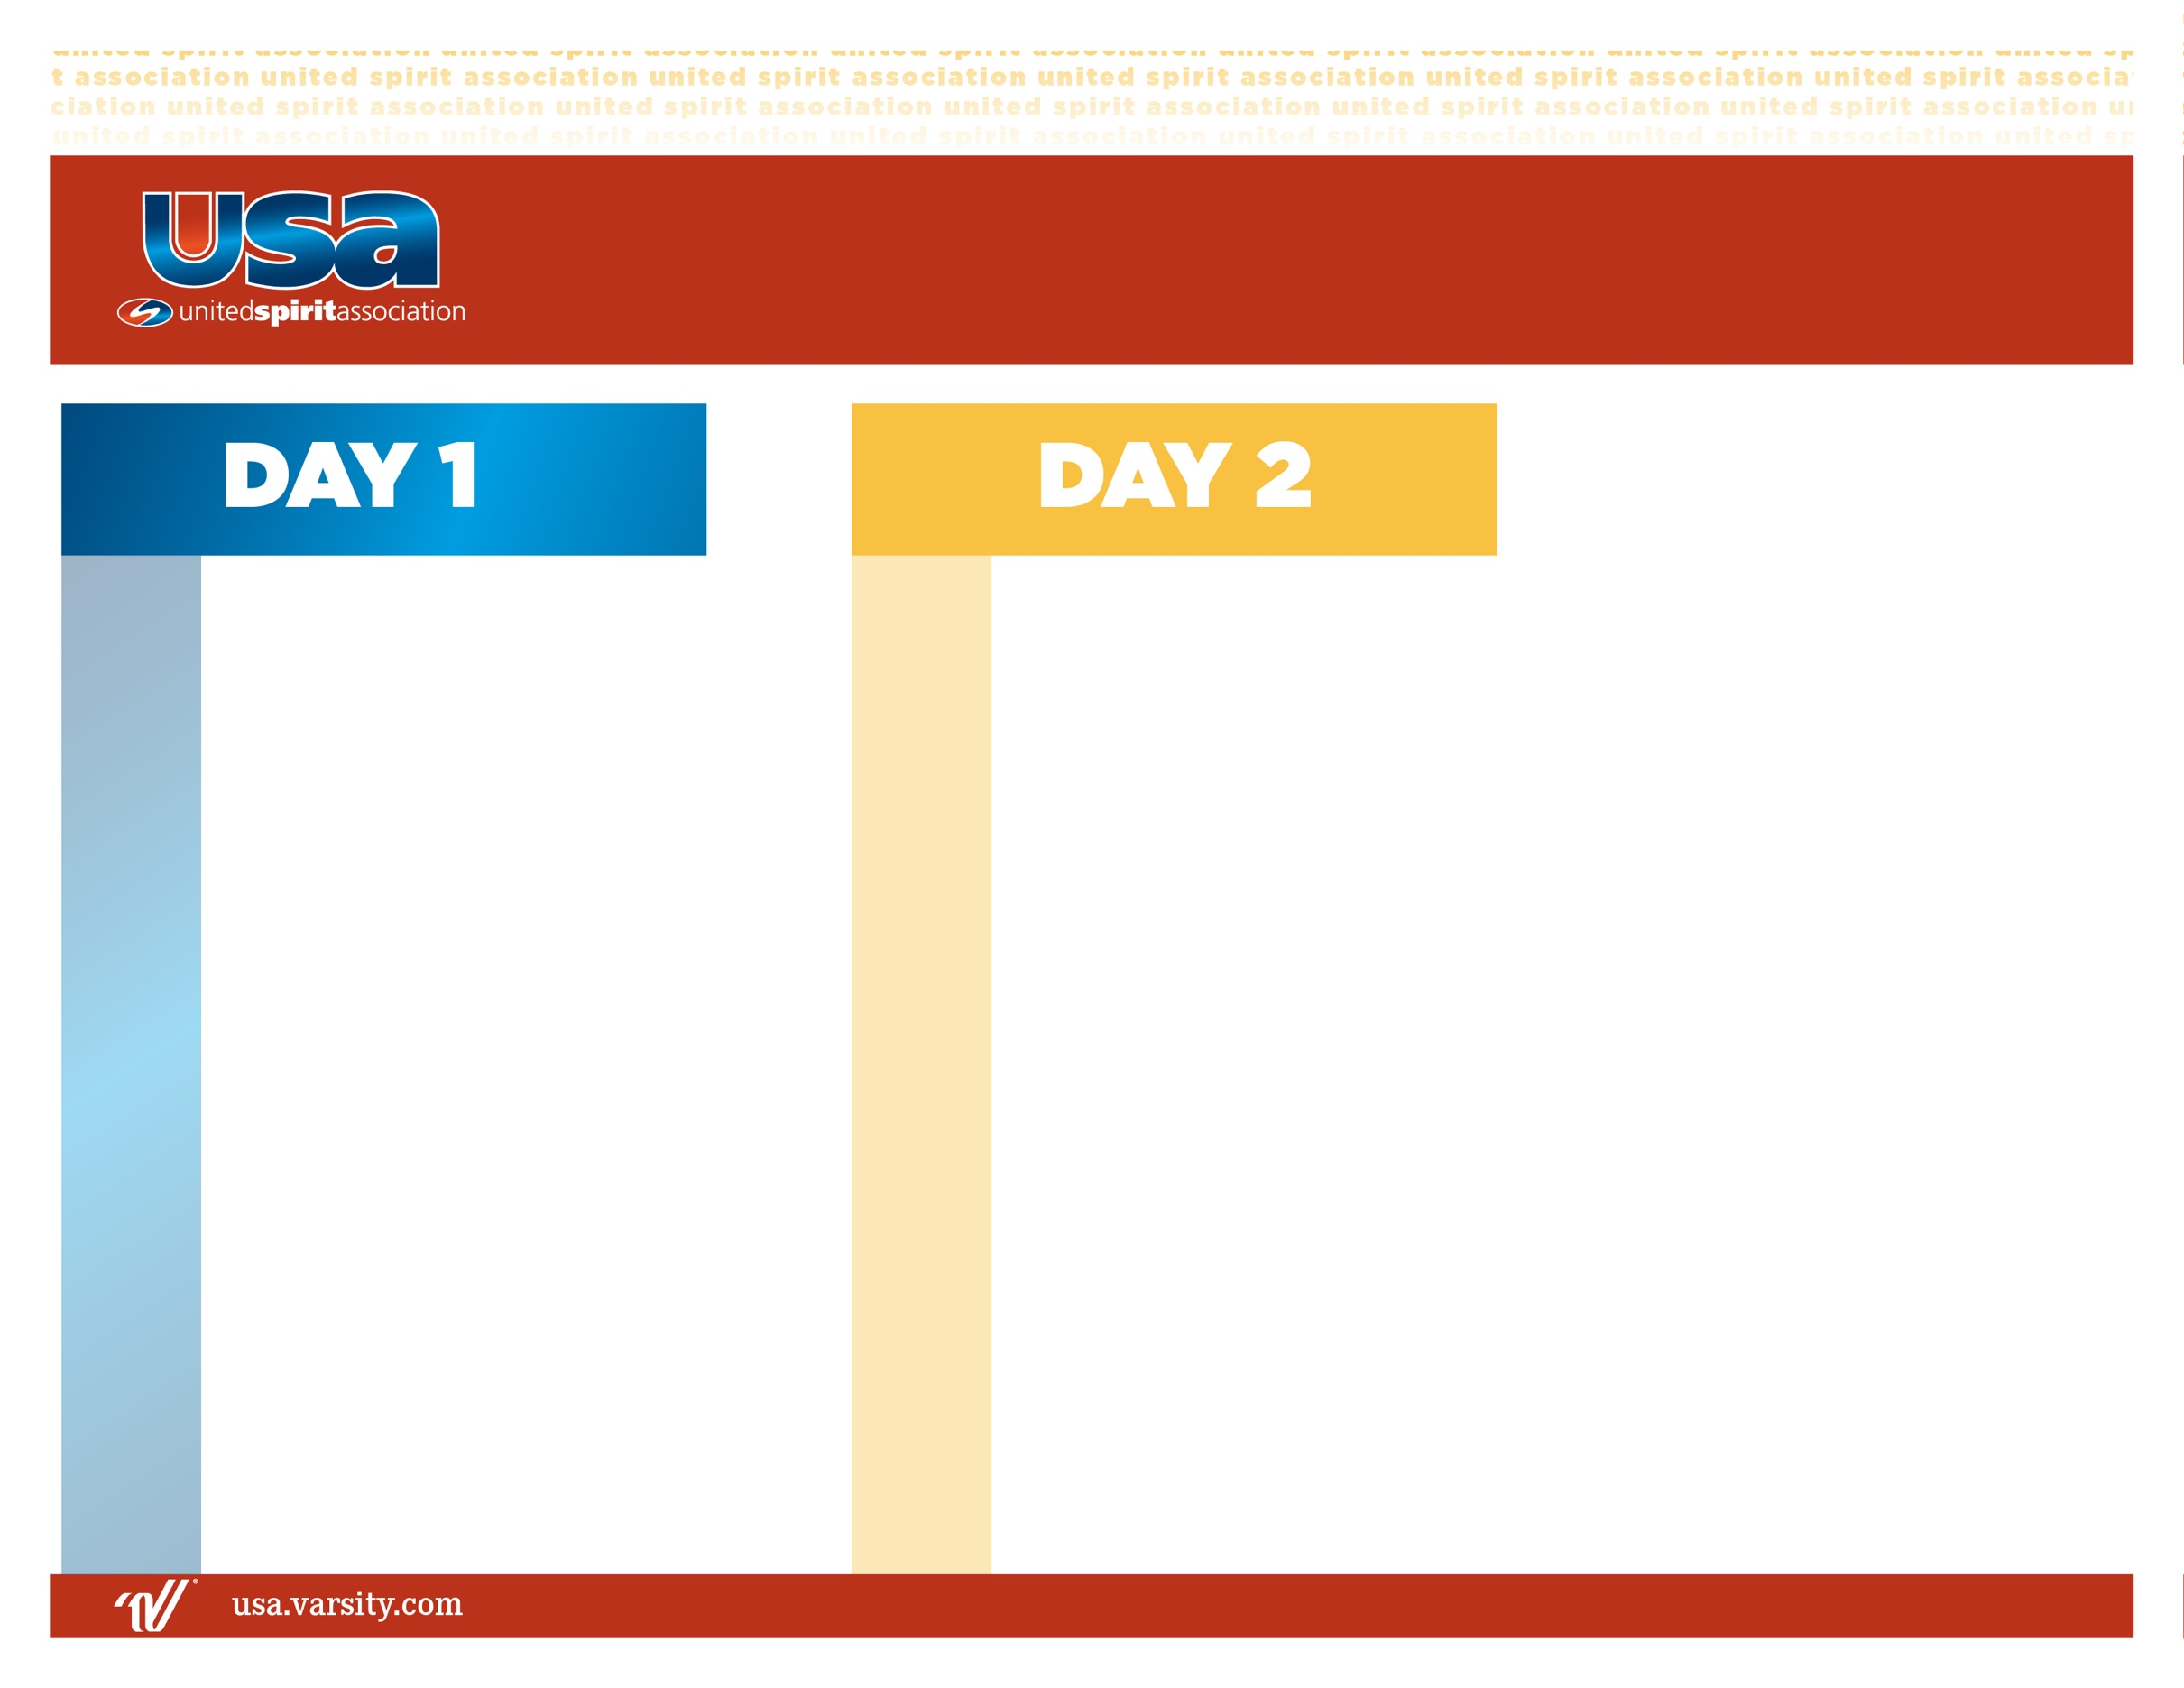

**BREAKFAST**

Warm-Ups

Understanding Your Band Director’s Vision

Leading By Example

Rehearsal Strategies II

Leading the Leadership Team

**LUNCH**

Situational Responses

Networking

Team Building & Inspiring Your Band

**DISMISS**

7:00 am

8:30 am

8:45 am

9:15 am

9:45 am

11:00 am

12:00 pm

1:00 pm

2:00 pm

2:45 pm

4:00 pm

Camp Registration Begins

Welcome and Meet & Greet

Building Community

Goal Setting

**LUNCH**

Building Confidence

Setting the Tone: Do’s & Don’ts of Band Camp

Rehearsal Strategies

Interpersonal Relationships & Leading Different Personalities

**DINNER**

Foundations of Communication

Conflict Resolution

**All Camp Meeting**

9:00 am

10:00 am

10:30 am

11:00 am

12:00 pm

1:00 pm

1:30 pm

2:30 pm

3:30 pm

5:00 pm

6:15 pm

7:00 pm

8:00 pm

**2025 Band Leadership**