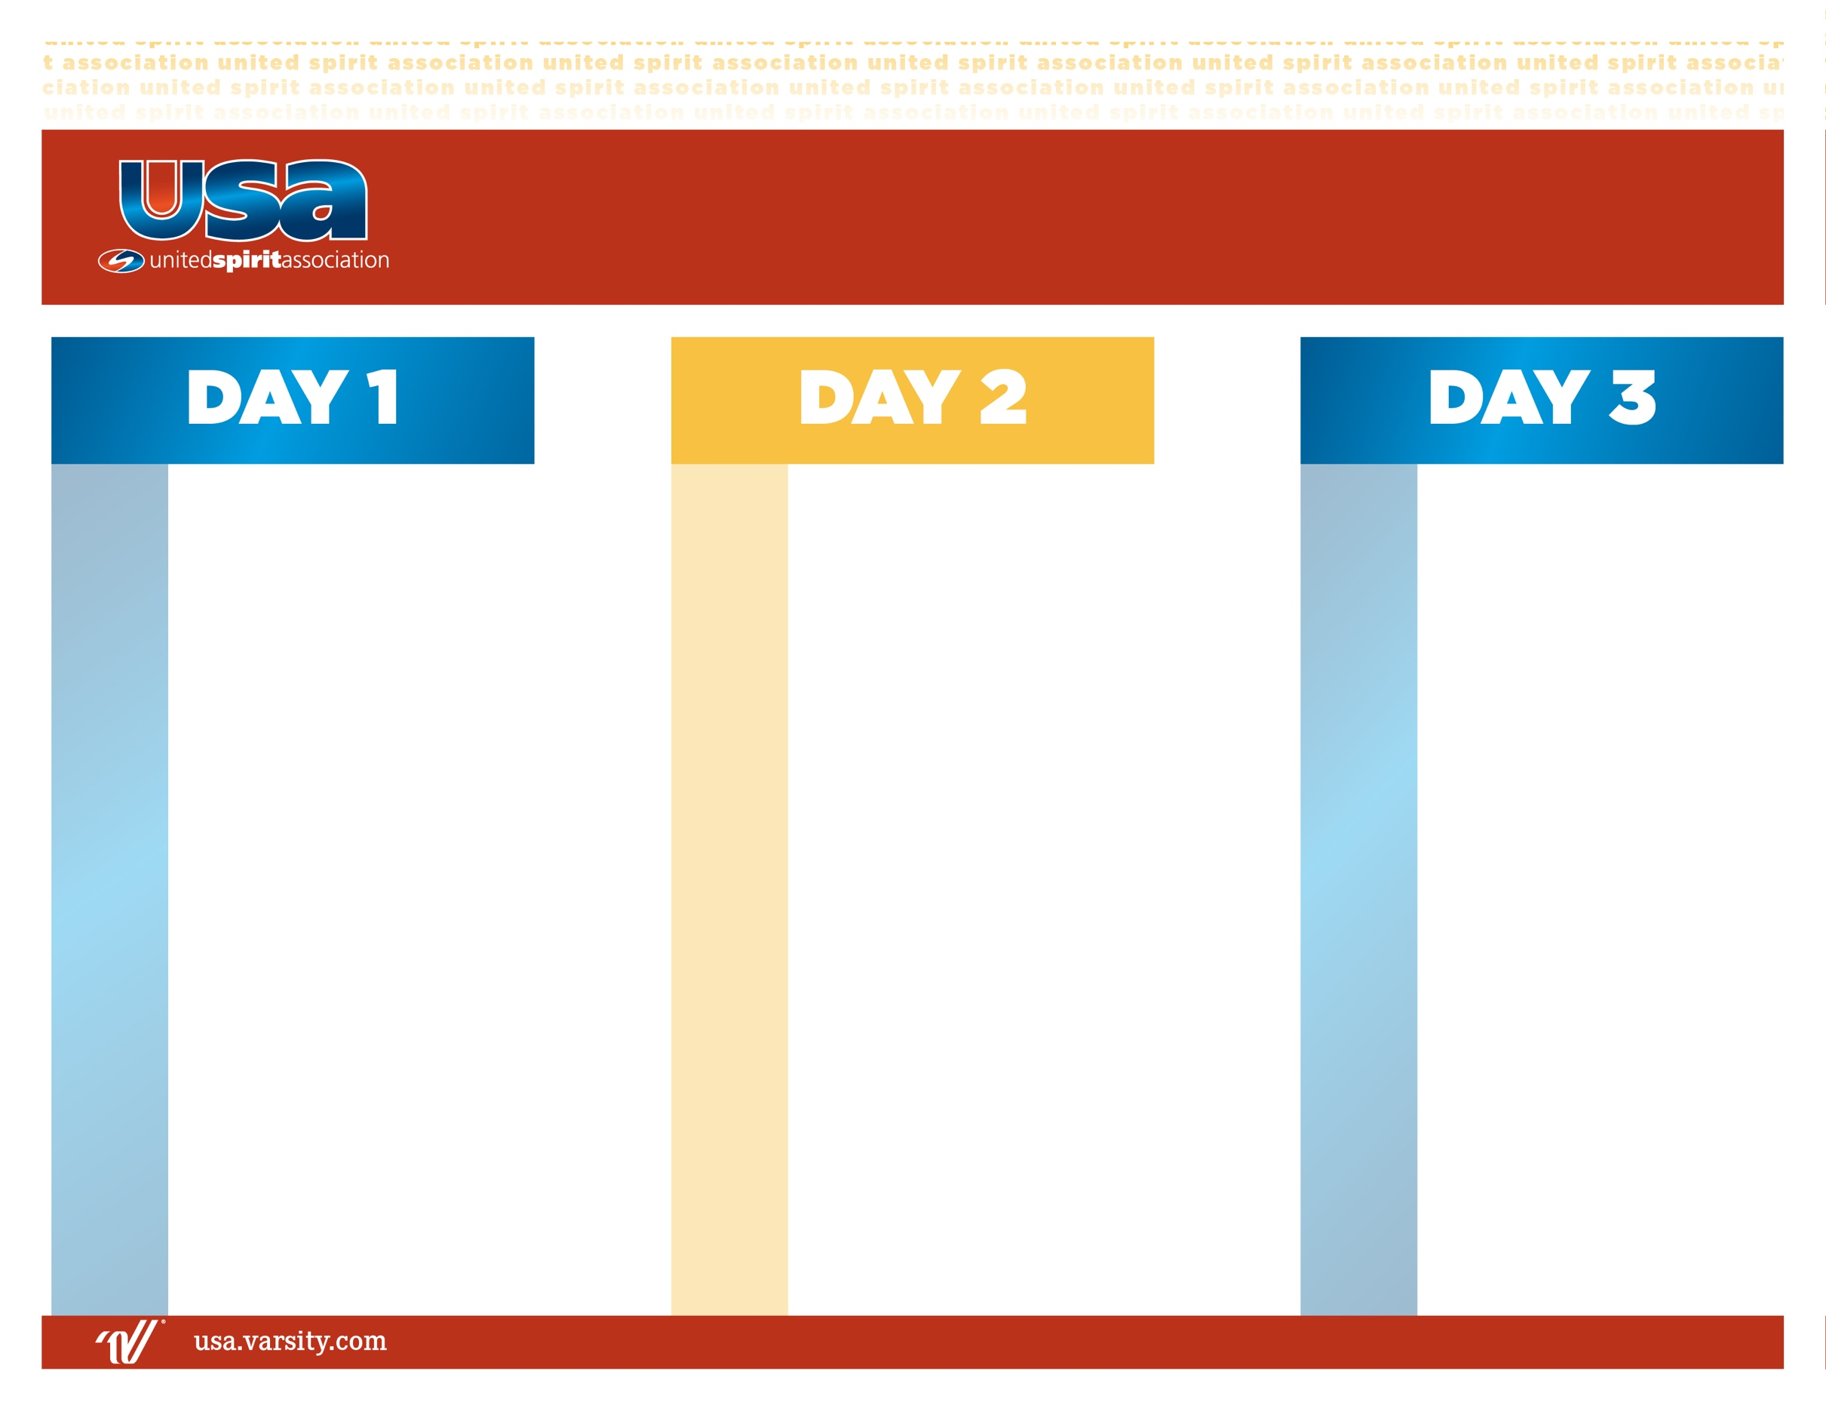

7:00 am

8:15 am

8:30 am

9:45 am

11:30 am

7:00 am

8:15 am

8:30 am

12:00 pm

1:30 pm

2:15 pm

3:00 pm

5:00 pm

6:15 pm

7:30 pm

9:00 pm

**BREAKFAST**

Warm-Ups

Block #3: Performance Review

(N) Field Show Review & Music Management

(I/A) Accelerated Field Show Review & Music Management

**LUNCH**

Band Leadership

Unity Groups

Block #4: Performance Review

(N) Music Management & Showmanship

(I/A) Showmanship & Performance Review

**DINNER**

Block #5: Performance Review

(N) Practice Evaluations

(I/A) Practice Evaluations

Unity Group Performance

**In Dorms**

1:00 pm

1:30 pm

4:00 pm

5:00 pm

6:15 pm

8:15 pm

9:00 pm

Opening Ceremonies

Block #1: Field Show Review

(N) Pulse & Pattern

(I/A) Pulse & Pattern Review

Unity Groups

**DINNER**

Block #2: Field Show Review

(N) Field Show Fundamentals

(I) Field Show Review

(A) Accelerated Field Show Review

Team Building

**All Camp Meeting**

**BREAKFAST**

Warm-Ups

Evaluation

Additional Resources

**Closing Ceremonies**

**2025 Drum Major | Field Show**