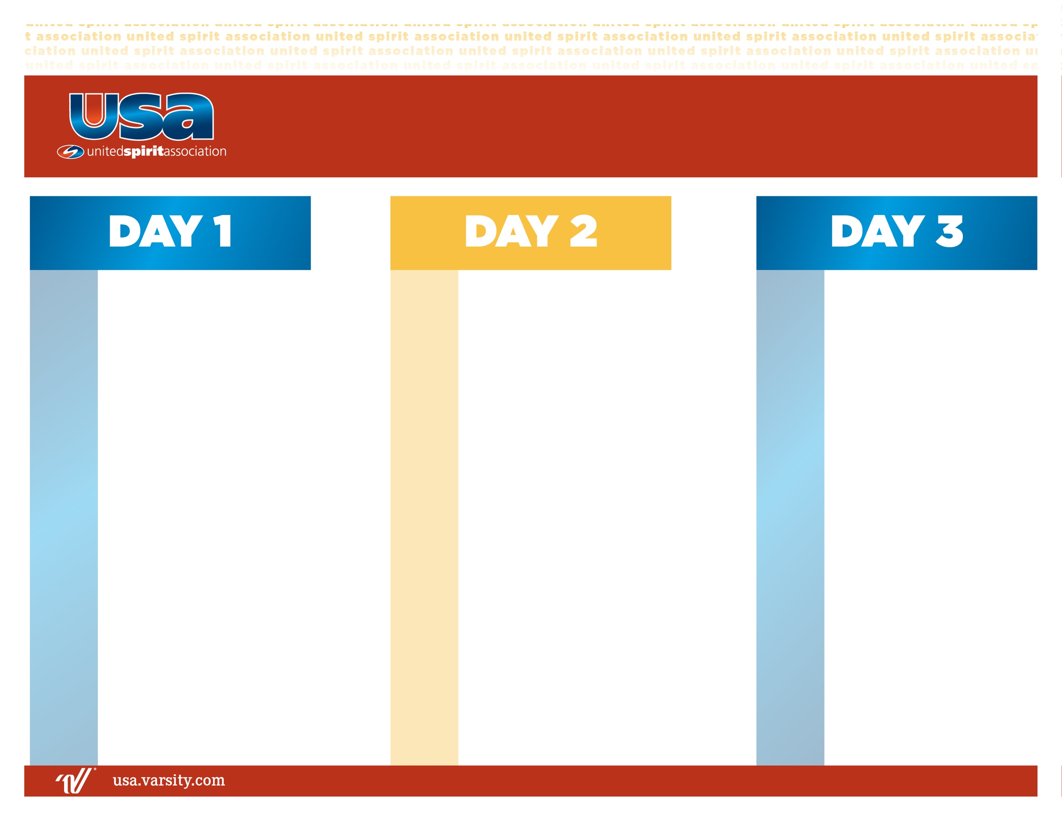

**BREAKFAST**

Warm-Ups

Block #3: Performance Review

(N) Routine Construction

(I/A) Routine Construction & Performance Review

**LUNCH**

Band Leadership

Unity Groups

Block #4: Performance Review

(N) Performance Review

(I/A) Showmanship & Performance Review

**DINNER**

Block #5: Performance Review

(N/I/A) Performance Review

Unity Group Performance

**In Dorms**

7:00 am

8:15 am

8:30 am

12:00 pm

1:30 pm

2:15 pm

3:00 pm

5:00 pm

6:15 pm

8:00 pm

9:00 pm

1:00 pm

1:30 pm

4:00 pm

5:00 pm

6:15 pm

8:15 pm

9:00 pm

7:00 am

8:15 am

8:30 am

9:45 am

11:30 am

**BREAKFAST**

Warm-Ups

Evaluations

Additional Resources

**Closing Ceremonies**

N – Novice

I – Intermediate

A – Advanced

Opening Ceremonies

Block #1: Parade Fundamentals & Review

(N) Basic Spins

(I/A) Accelerated Spin Review

Unity Group

**DINNER**

Block #2: Parade Review

(N) Parade Basics

(I) Parade Review

(A) Accelerated Parade Review

Team Building

**All Camp Meeting**

**2025 Drum Major | Parade**