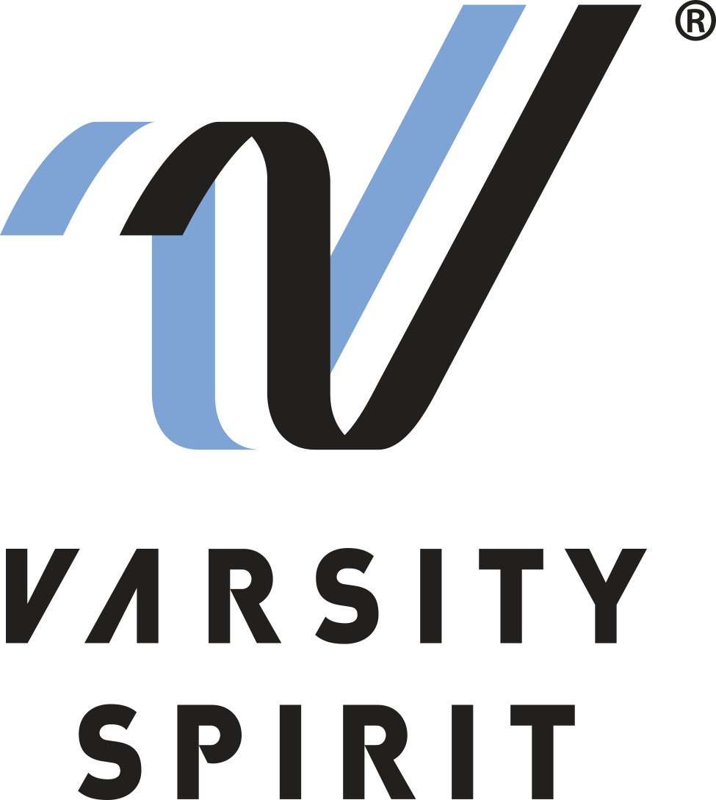**FOR IMMEDIATE RELEASE:**

**Press Release:** *This is an example of a press release. Simply add your details to the bracketed sections (delete the brackets), and any additional information that makes this experience unique. Contact your local news outlets (newspaper, radio stations) in your area with a good, clear photo of the athlete.*

*(Note – search your city, state “local news outlets” in google, and follow the steps to submit content. This may vary from news outlet to news outlet.)*

*Within the release below, there is a space for you to add your own quote. Please do not change any text that is not within brackets.* ***Delete this paragraph before sending.***

**Contact:**  
Catherine Morris

Varsity Spirit Special Events

[cmorris@varsity.com](mailto:cmorris@varsity.com)

[www.varsity.com](http://www.varsity.com)

**LOCAL MARCHING BAND TO PERFORM IN THE 2025 VARSITY PERFORMING ARTS CELEBRATION OF BANDS AT THE WALT DISNEY WORLD® RESORT**

**City, State –** [School Band Name _____________________] in [City, State _____________________] is one of the first ever marching bands to represent Varsity Performing Arts in the 2025 Celebration of Bands Performance at the *Walt Disney World*® Resort in Orlando, Florida from November 23-26, 2025.

Students invited to perform at this exciting event are part of a select group of marching bands from across the nation to experience performing with other marching bands like never before!

[School Band Name ___________________] is set to take center stage in an exclusive performance at the iconic Disney’s Magic Kingdom Park! Beyond the thrill of performing in one of the most magical settings in the world, participants will learn from world-class clinicians, connect with fellow talented bands in attendance and explore award-winning theme parks.

*[Insert quote from participant here, explaining what they are most looking forward to, or how they feel about being a part of the Varsity Spirit Spring Break Performance.]*

For more information about the Celebration of Bands, visit [www.varsity.com/celebration-of-bands/](https://www.varsity.com/school/camps/special-events/celebration-of-bands/).

**About Varsity Spirit**Memphis-based Varsity Spirit, the driving force behind cheerleading’s dynamic transformation into the high-energy, athletic activity it is today, is the leading global source for all things spirit, including cheerleading, dance team, performing arts and yearbook. A division of Varsity Brands, Varsity Spirit is a leader in uniform innovation, as well as educational camps, clinics and competitions, impacting more than a million athletes each year. Focused on safety, entertainment and traditional school leadership, Varsity Spirit’s employees have been dedicated to celebrating spirit through its brands since 1974. For more information about Varsity Spirit or Varsity Brands, please visit [varsity.com](http://www.varsity.com) or [varsitybrands.com](https://www.varsitybrands.com/).